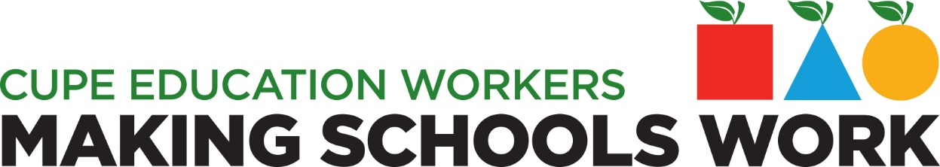

SPECIAL NOTICE
CUPE LOCAL 1238

If you were employed by the Lambton Kent District School Board between the dates of September 1, 2012 and August 31, 2014 and your Union was the Canadian Union of Public Employees (CUPE)Local 1238, you are eligible to share in the financial settlement reached by CUPE for the breach of your Charter Rights.

The fastest way to find out if you are on the list to receive compensation is to visit our website:
bill115.cupe.on.ca

Deadline to receive Correction Request is November 10, 2017.

_{Formatted only by hr/cope491}

