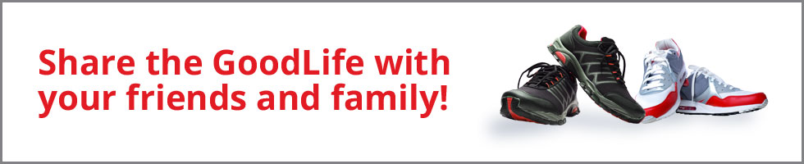

Buy a discounted one-year GoodLife membership with Edvantage and you'll be automatically entered to receive ﻿one of two iPads﻿ AND a ﻿free membership﻿ to share with a friend or family member! ﻿PLUS: ﻿Purchase a new membership for your spouse and/or children between the ages of 12 and 25 and receive more chances to win!
Get started today at www.edvantage.ca/goodlife-share

