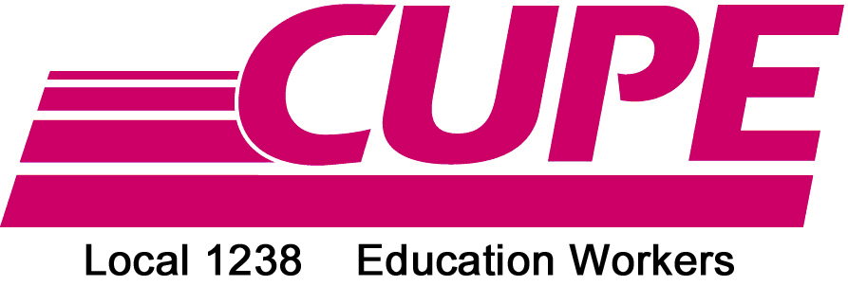

FREE SKATE
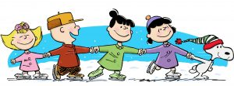

Sunday, January 21st, 2018

3:00-5:00p.m.

William K. Erickson Arena

341 Delaware Ave.

Chatham, ON N7L 2W8

This is a private event for CUPE 1238 members, friends and family.

We look forward to skating with you!

Hot beverages will be provided.

Questions? Contact any CUPE 1238 Executive Member.

